vllm serve /workspace/shared_assets/models/Qwen/Qwen3-VL-8B-Instructt \
--dtype bfloat16 \
--max-model-len 16384 \
--max-num-batched-tokens 16384

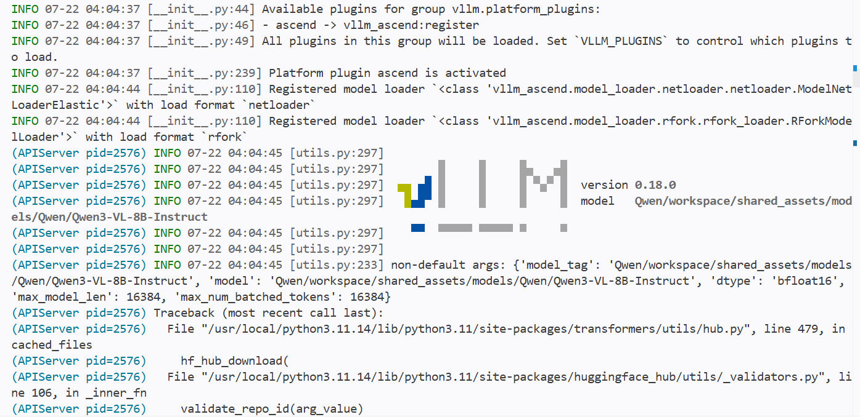

vllm bench serve --model /workspace/shared_assets/models/Qwen/Qwen3-VL-8B-Instruct --dataset-name random --random-input 200 --num-prompts 200 --request-rate 1 --save-result --result-dir ./

